Interim Report

# Technical Achievement

Up to this point, much of the technical achievement has been through testing and experimentation, learning new skills throughout the project means that it has been necessary to run experiments first before implementing anything into the working product.

Some of the technical achievements up until this point:

* The categories displayed on the sidebar navigation are displayed using AJAX and JSON. The database is queried initially for all parent categories (i.e. ones with a null value in the parent_cat_id foreign key field) and a selection of those are displayed through putting the data into a JSON object and then using AJAX to retrieve the object and display it on the page.
  + JavaScript used to handle click events, when a category link is clicked that category’s sub-categories are loaded in place of the existing category links, can continue drilling down into subcategories.
* 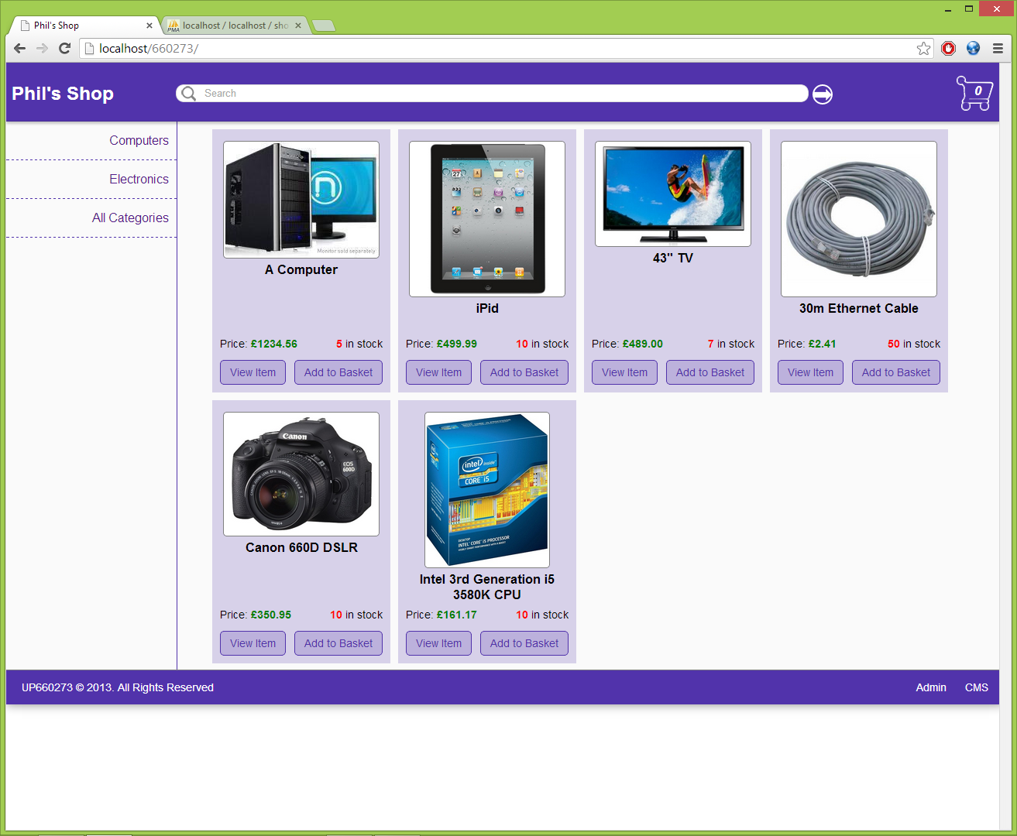Products are loaded and displayed using AJAX and JSON also, JavaScript handles when the document is ready and initially loads all products on the page (pagination to be added later) displaying the appropriate product image, name, price and stock quantity.
  + 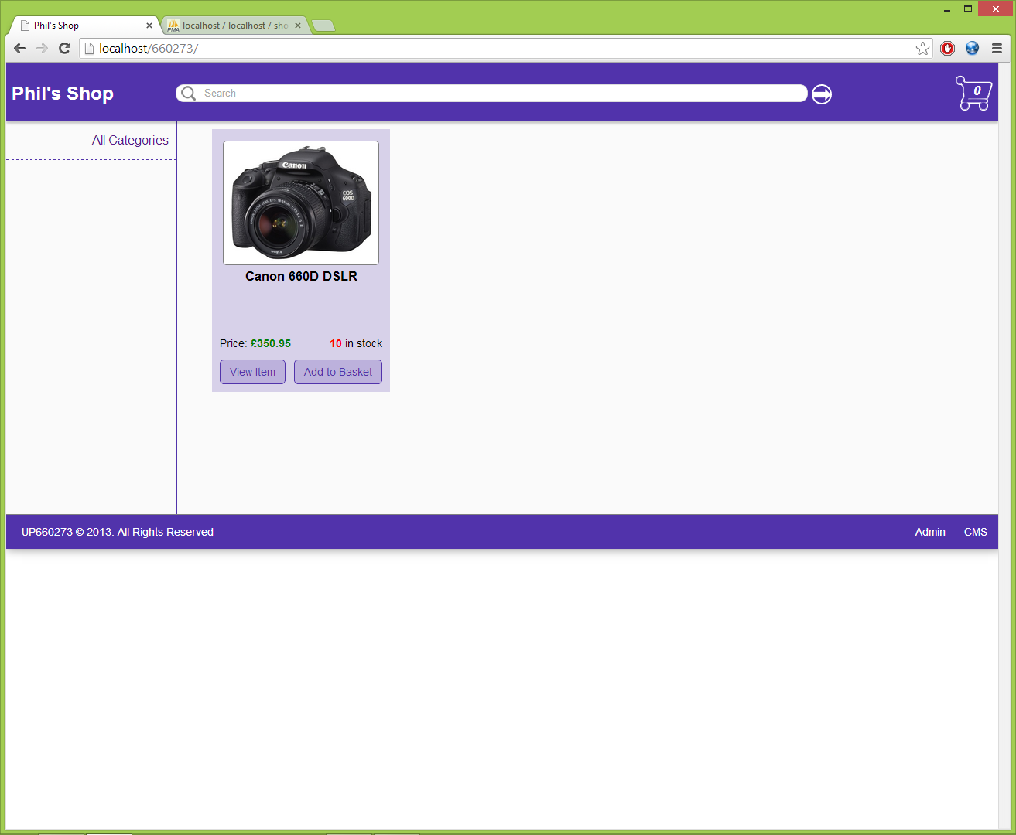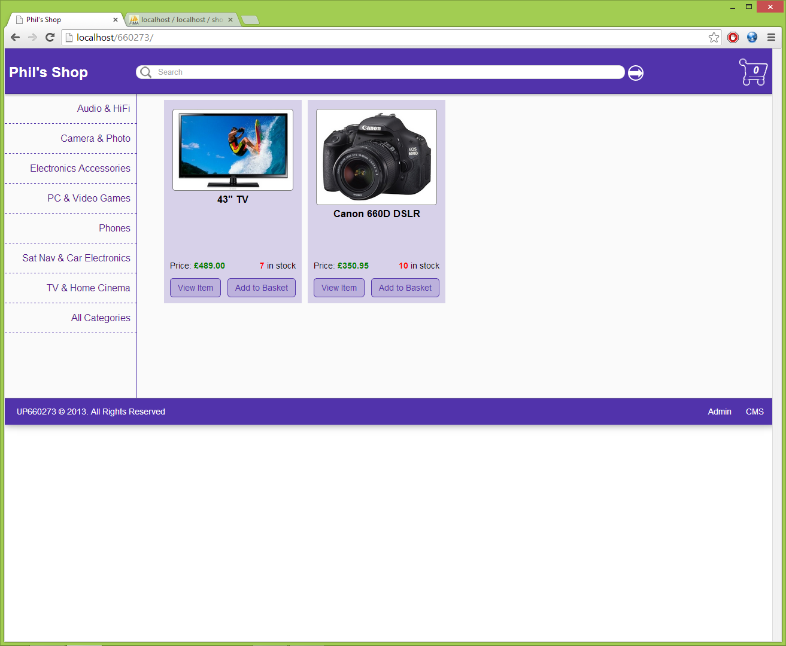When click event on category button is fired, new set of products loaded (currently a new query on the DB to create JSON object used by the AJAX script) to include all products within the parent category (i.e. products which are directly related to the parent category) and also all products which are related to any of subcategories of the parent category.

View in Camera & Photo category. No page refresh required as using ajax fired by JS handling click events.

Partial view of products in Electronics & Computers parent category. Note: Camera product

View in Electronics category

## Technical Achievements in Testing and Experimentation:

* Site customisation & setup:
  + Using PHP and header location to redirect to an admin setup page on failure to connect to shop database (page would be protected). Setup page allows admin to enter the host IP address of where the database is stored as well as the username and password and name of the database. If the database does not exist then it is automatically created. They are also given the choice if they wish to insert any sample data into the database.
  + The setup additionally allows them to customise the shop/website. They are able to set the shop name, currency and theme
  + This data is stored in a config file
    - CSS is dynamic, accesses this config file to get colours for the physical appearance of the site
    - Other variables (shop name, currency) are used elsewhere where appropriate (i.e. shop name in head and page header to display at the top of the page and as window name)

# Management Report

## Current Progress

The chosen lifecycle model was ideal for this project, given the nature of the incremental learning and application through the unit. This fits well into the iterative and incremental approach to development that DSDM takes. However given the lack of sufficient experience in both the technologies and the lifecycle model the plan has had to change and adapt somewhat over the course of the project so far, given the following reasons:

* Unforeseen personal & family issues which put the project on hold for several days
* Not having specific skills to implement desired features at the time they were intended according the initial plan
* The initial plan setting out a higher workload in the first iteration of the project development that was unmanageable given the workload from other units and my job

Fortunately the initial plan did leave room for additional time for the entire project to be completed before the final deadline, however now that time has been mostly used up and so certain features may have to reprioritised and possibly some dropped from the final product in the case of any future circumstances that have not be foreseen or the negative effects of such cannot be sufficiently mitigated.

Although there was some delay in the project, the project is now very close to be back on schedule due to action I have taken to mitigate the impact of previously unforeseen situations, those being:

* I have personally prioritised the project since the Christmas ‘break’ and therefore additional man hours have been spent working on the project each day compared to what was expected from the initial plan, in order to complete the tasks in the planned number of days
* 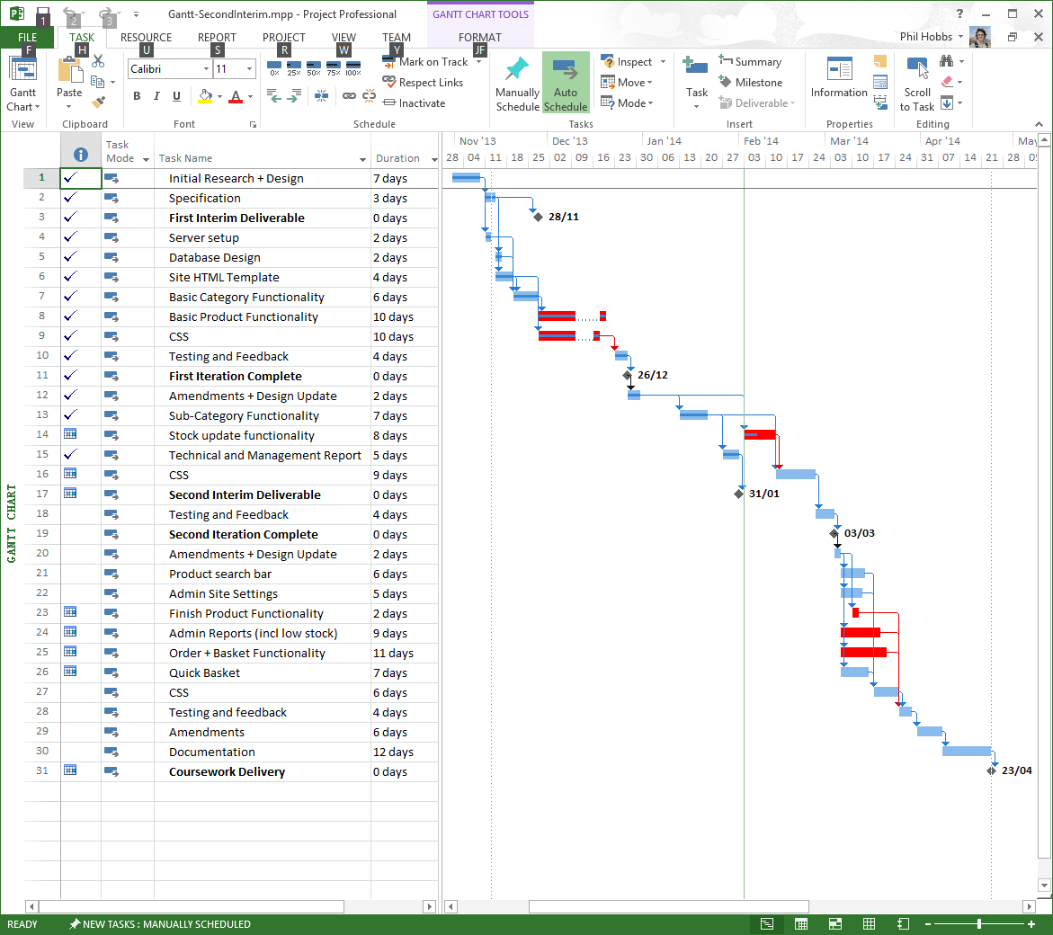The plan has been adapted to allow all features (currently) to still be implemented in the final iteration. Features that I was unable to implement earlier due to not having yet obtain skills to do so are not set to be completed in the final iteration
* Here is the project plan as it stands (significant changes are red):

## Lessons Learned:

* When taking an iterative approach, not to include too much work in the initial iteration of the project
* Allow more time for experimentation in the plan itself
* When creating initial plan, try to predict when the required knowledge, skills and resources will be available and plan to complete features which require them when such things are available.